Cameron Ake and Diana Lin
Machine Learning 1, Period 3
Dr. Yilmaz
8 January 2024

An Extra-Random Forest: Using Skewed Probability Distributions to Add Randomness to Splitting in Random Forests

Machine Learning Quarter 2 Project

Abstract

Random forests currently split datasets by determining which attribute has the strictly highest value of the information gain, Gini impurity, or some other metric when the dataset is split on that attribute. Since random forests rely on small random changes in individual trees and then aggregating the results, we examined the possibility of using probability distributions to determine whether to split on the attribute with the highest information gain, the second-highest information gain, etc. in order to add an additional element of randomness to the random forest creation process. Using the common diabetes dataset, we implemented a geometric distribution (p = 0.5), a Poisson distribution (λ = 5.5), a binomial distribution (p = 0.5), and a uniform distribution (essentially, splitting on randomly selected attributes), as well as a random forest without using a geometric distribution. Compared to the regular random forest’s mean accuracy of 71.2%, the geometric distribution random forest had mean accuracy 71.1%, the Poisson distribution random forest had 70.9%, the binomial distribution random forest 70.9%, and the uniform distribution random forest 70.7%. We found that each of the random forests that utilized probability distributions performed slightly worse than the typical random forest, but these forests also had more spread-out distributions, meaning they had a higher probability of performing particularly well.

Introduction

Currently, random forests aim to improve upon decision trees by adding several random elements to the tree-creation process and aggregating the results. This allows for improved accuracy due to its reduction on focusing too specifically on particular aspects of the data; random forests are also less likely to overfit to the data.

While this is effective, random forests may produce better results if trees are more random. The random forest algorithm always constructs the most “optimal” trees, wherein the tree is 100% fit to the input data. Random forests are considered more resistant to overfitting than decision trees, but the smaller, individual trees in random forests are still completely conformant to the input data, which may still lead to less-than-optimal results when predicting on testing data. Instead, we propose to utilize better methods to construct less well-fit trees for random forests—methods to make tree creation more random—and thus potentially improve the performance of random forest classification. A new random forest model that could outperform existing models would indeed be a significant addition to the machine learning community and the ability of programmers to optimize their models.

The input to our algorithm will be data on the health of a patient. We then use a random forest to output a prediction of whether or not they tested positive for diabetes.

Related Work

Most random forests, like most machine learning models, use random train/test splitting to ensure the model does not overfit. Much research has focused on the nuances of train/test splitting. Indeed, one researcher explored the extent to which improper train/test splitting can affect model performance; in some cases, randomly splitting train and test data can be proper, but in their attempt to use a random forest for regression to fit to a sinusoidal function, an entire section of the function had to be set apart as the testing set in order for the regression to explore the importance of the x-value in predicting y (Rao 2-4). Another step in the machine learning process that can be randomized is feature selection; one team of researchers found that a wrapper feature selection algorithm that calculates various probabilities in order to determine feature importance was effective and beneficial for greatly improving time efficiency of random forest creation (Zaim et al. 2-4).

However, comparatively little research has been conducted on what we actually want to randomize in this paper: different ways of splitting on attributes. In a decision tree, each “level” of the decision tree splits the data based on some attribute. The decision on which attribute to split on is crucial and impacts how the model will predict testing values. Most models simply opt to split on whichever attribute has the highest value of some function: the trees search for which attribute has the highest information gain, Gini impurity, etc. (Verikas et al. 330-346). In a random forest, though, more randomness in the function could be beneficial to further reduce overfitting.

Indeed, a few researchers have explored related concepts. One paper explored randomizing decision tree splitting for continuous data, but rather than adding randomization to any metric of the data, they randomized the “split point,” i.e. where groupings would be made in order to split the data, and it proved fairly effective (Ishwaran 75-107). However, this strategy only applies to continuous data; our investigation will focus on discrete data. Meanwhile, some researchers have explored Bayesian decision trees, where models split data so they can use Beta prior distributions to predict test values of their data. In this case, however, the splitting itself is not randomized; rather, training values are aggregated to form probability distributions and probability calculations are used to select a tree with the best overall probability metric. This is also a creative way of building models for unique problems, in this case for predicting stock prices. Once again, it is difficult to communicate and never involves randomizing the splitting on any attributes (Nuti et al. 1-8). From altering split metrics to randomizing “split points” to probability-based feature selection, probability distributions and randomization are fairly common for experimental random forest algorithms, but none currently aim to add random elements to the process of selecting attributes to split on.

Dataset and Features

We examined the diabetes dataset, a relatively commonly found dataset that has been used in papers examining learning algorithms before (National Institute of Diabetes and Digestive and Kidney Diseases). This dataset is useful because it has two class values, making it relatively simple to examine machine learning models, and it is easy to find and thus to replicate results with; it also does not require complicated preprocessing. The dataset originally came from the National Institute of Diabetes and Digestive and Kidney Diseases; our version of it came from Kaggle.

In this dataset, each instance is an adult woman of Pima Indian heritage who was tested for diabetes. Various values such as age, BMI, diastolic blood pressure, etc. were measured, and the class values are whether or not the patient tested positive for diabetes. We included all features in the construction of the model, as there were not enough features to necessitate dimensionality reduction. An example instance is below:

id preg plas pres skin insu mass pedi age class
1 6 148 72 35 0 33.6 0.627 50 tested_positive

The original dataset we used had 768 instances; we performed an 80/20 train/test split, resulting in 614 training instances and 154 testing instances. Normalization and data augmentation did not prove necessary, but the dataset was discretized using equal width binning with 10 bins for each feature in order to accommodate the categorical splitting techniques that the model used.

Methods

A decision tree is a machine learning model that classifies data based on “splits” it has made on the data. In order to create a model, the process to create a decision tree model begins by finding which attribute is most “helpful” to predict class, using some indicator like information gain. Information gain, which we used in this project, measures the “purity” of the datasets that result when the dataset is “split on” some attribute. For instance, the model may examine how different ages tend to test for diabetes.

The entropy ($H$) of a dataset is given by the following formula, where p_{i} represents the proportion of some given class value in the dataset.
$H(C)=\sum_{i}^{n}{}p_{i}log_{2}(p_{i})$ (Dash)
This measures to what extent a given dataset tends to have the same class value. High entropy means a dataset has more evenly distributed class values; low entropy means a dataset tends to have many of the same class values. The model, then, “splits” the dataset based on which values of some attribute it has (such as which age each patient is). For each value of that attribute, the entropy of the resulting subset of the dataset is measured; the weighted average of these values is taken to provide an overall entropy value after the split. Then, the information gain, which measures how much the subsets of the dataset tend to have the same class value, is given by the following formula:

$Gain(C, A) =H(C)-H(C|A)$

Whichever attribute has the highest information gain when the dataset is split on that attribute, then, is the attribute that is most useful in predicting which class value any given instance will have, as each value of that attribute will have particularly similar class values. The model then splits the data on that attribute and proceeds in a recursive fashion: it then finds the best attribute to split on for each individual subset of the dataset. This process continues until no attributes are left, a maximum depth is reached, or all instances have the same class value. To predict the class value of a testing instance, a decision tree simply examines the value of the attribute that the tree splits on—if the algorithm determined that age was the best attribute to split on, the model examines the instance’s age value and proceeds to whichever branch of the tree corresponds to the age value. This continues until the instance has proceeded as far as possible down the tree, at which point the testing instance is predicted to have whichever class value was most common for training instances at that point in the tree.

Our model was based on a random forest model, which generates a collection of randomly altered versions of the original dataset, then generates a decision tree for each version of the dataset and outputs the prediction of the majority of the trees. The former step in that process involves repeatedly and randomly creating new datasets from the original training dataset (using random sampling with replacement), a process referred to as “bagging”, as well as randomly selecting certain attributes of the original dataset to include while ignoring the other attributes. Each of these datasets is then fed into a decision tree creation algorithm, producing the trees that the model will use to predict class values.

In order to create more randomness in the tree creation process, then, we implemented another semi-random process of determining which attributes for trees to split on. As described above, every time a decision tree determines which attribute it will split on, it chooses the attribute with the highest value of some metric such as information gain. This process has no randomness in it; instead, random forests currently focus on creating trees based on data that has been randomly manipulated.

By using probability distributions to randomly, occasionally split on attributes that do not have the absolute highest information gain—sometimes selecting the attribute with the second-highest, the third-highest, etc.—we hoped to add more randomness to this selection of which attributes to “split on” in order to improve the performance of random forests. We first preprocessed our data by using an 80/20 split and discretizing our data. We then built a more typical random forest model for the diabetes dataset as a baseline for our research. Afterwards, we built other random forests using varying random tree-creation methods.

The “extra-random forests” we created selected attributes using various distributions: one used a binomial distribution, one used a Poisson distribution, and one used a geometric distribution. We also used a uniform distribution as a baseline for what happens if the attribute to split on is selected completely randomly.

With the right parameters, these distributions are skewed right, meaning most of their values cluster on the lower end. We plan to randomly select values using these distributions to derive the choice probability. For instance, if the geometric distribution randomly outputs some value such as 1, 2, 3, etc., the output value would correspond to an attribute to split on (highest info gain, second-highest info gain, third highest info gain, etc.), as shown in fig. 1.
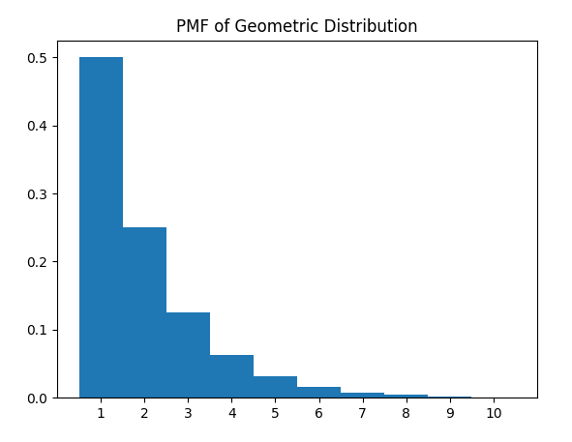
Fig. 1. PMF of geometric distribution generated with 10 attributes.

It is important to note that the binomial and poisson distributions are centered in the middle. To get a distribution that would pick the best attribute with the highest frequency, we translated these distributions so that we consider PMF values to the right of the center of the distribution.

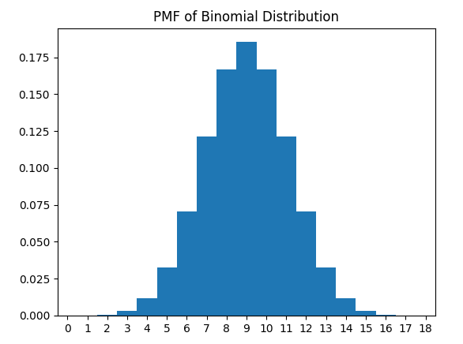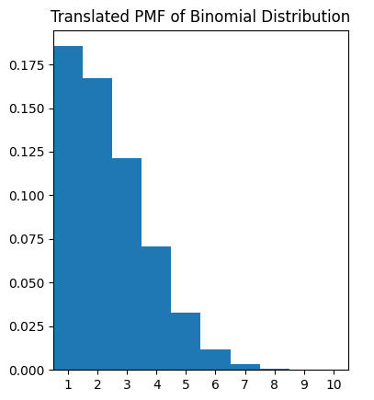
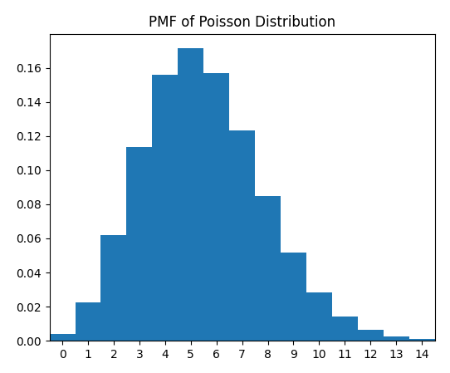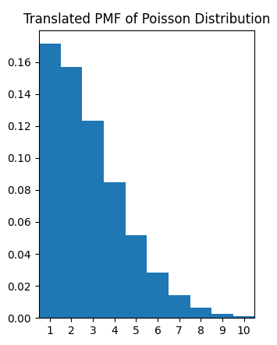
Fig. 2. PMF of other distributions generated with 10 attributes.

In this example, randomly generating a 1, 2, or 3 would again mean splitting on the attribute with highest information gain, second-highest information gain, third-highest information gain, etc., respectively, with generating a 1 again having the highest probability.

Thus, the trees made their attribute splits using a semi-random algorithm, but they generally tended to select attributes with higher information gain, meaning they still tended to select “good” attributes in the long run. We tested and evaluated their performance using various performance metrics, most notably accuracy and sensitivity, as well as the confusion matrix. We created many models of each type in order to demonstrate how accuracy varied from forest to forest. It was not feasible to use ROC AUC in this context, as it would have required an implementation with libraries and we chose to generate a large number of random forest models of each type.

Results and Discussion

We chose not to automatically tune the random forest hyperparameters with sklearn’s RandomizedSearchCV because that would result in the hyperparameters being tuned for best performance specifically in the regular model, thereby skewing our results. Instead, we manually chose them. Generally, the recommended number of features to consider per tree in a classification problem is equal to the square root of the total number of features. For our chosen dataset, the number of features we consider per tree is 3. Because the number of features and, thus, the possible depth of the tree is so low, we also mitigate overfitting via these parameters.

Because the dataset we chose is fairly small, with only 615 samples, we also chose a small number, 5, for the number of samples to consider per tree. Furthermore, we chose to use 50 trees for our forest because we found that the accuracy plateaus with more trees, as shown in the figure below. The accuracy plateaus near the same rate for each version of the random forest, indicating that a similar number of trees should be used for different types of forests on the same data.
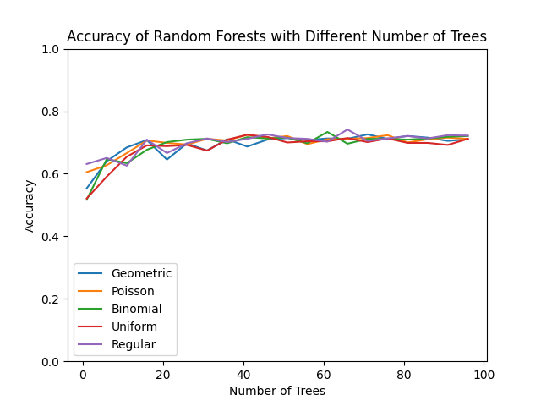
Fig. 2. Number of Trees vs Accuracy graph.

We ran 300 trials for each version of the random forest and used the accuracy and precision of each random forest to assess the effectiveness of each version.

The accuracy is given by the following formula, where $TP$, $FP$, $FN$, and $TN$ are equal to the number of true positives, false positives, false negatives, and true negatives, respectively.

$Accuracy=\frac{TP+TN}{TP+FP+TN+FN}$

We took the average of the accuracy over the 300 trials, and we found that it was generally about the same for each type of tree. The regular random forest had the highest average accuracy, and the uniform random forest had the lowest average accuracy. We suspect that this is because the “regular” random forest is less likely to build trees that are seemingly suboptimal, whereas the uniform random forest is more likely to only build trees that are suboptimal.

The standard deviation for the regular decision tree is equal to or lower than that of the trees using the probability distribution splitting method. This indicates that the probability distribution splitting method did, in fact, add more randomness to the trees. The standard deviation is roughly negatively correlated with the probability of picking the “best” choice of attribute to split on. With three attributes, the geometric random forest had a 50% probability of picking the option with the highest info gain. On the other hand, the binomial distribution had a much lower probability of picking the option with the highest info gain, with a 37.5% chance. This higher standard deviation for forests with distributions less concentrated around the left side makes sense; it means these distributions have higher probabilities of selecting attributes with lower information gain and thus making trees that vary more.

We also calculated the sensitivity for each of the forests. Sensitivity is given by the following formula:
$Sensitivity=\frac{TP}{TP+FN}$

The average sensitivity for all four random forests is fairly low, indicating that random forests tend to misclassify many truly positive diabetic values as non-diabetic.

Feature Selection Method | Regular | Binomial | Geometric | Poisson | Uniform
Average Accuracy | 71.210% | 70.855% | 71.119% | 70.913% | 70.706%
Accuracy Std. Dev. | 0.0234 | 0.0256 | 0.0252 | 0.0258 | 0.0253
Accuracy Range | 0.156 | 0.182 | 0.156 | 0.188 | 0.175
Average Sensitivity | 0.211 | 0.171 | 0.193 | 0.171 | 0.175

While we did examine the matrices of individual forests, it was difficult to see any obvious pattern because each forest varied significantly from others. Because of that, we instead took the mean values for each statistic in the confusion matrix, as shown on the tables on the next page. These mean values did not vary significantly between each type of forest.

Regular
 | tested_positive (Predicted) | tested_negative (Predicted)
tested_positive | 9.913 | 37.087
tested_negative | 7.25 | 99.75

Binomial
 | tested_positive (Predicted) | tested_negative (Predicted)
tested_positive | 8.023 | 38.977
tested_negative | 5.907 | 101.093

Geometric
 | tested_positive (Predicted) | tested_negative (Predicted)
tested_positive | 9.077 | 37.923
tested_negative | 6.553 | 100.447

Uniform
 | tested_positive (Predicted) | tested_negative (Predicted)
tested_positive | 7.937 | 39.063
tested_negative | 5.81 | 101.19

Poisson
 | tested_positive (Predicted) | tested_negative (Predicted)
tested_positive | 8.047 | 38.953
tested_negative | 5.84 | 101.16

The graphs of how the individual forests’ accuracies are distributed reveals information of interest that is hidden when solely looking at the performance metrics. For the accuracy distribution of the regular random forest, we see that most accuracies tend to hover in a very tight range with a few values substantially lower than the rest. On the other hand, the accuracy distributions of the probabilistic trees all have more forests that fall outside of the comfortable “middle” range, though it is still not a large number.
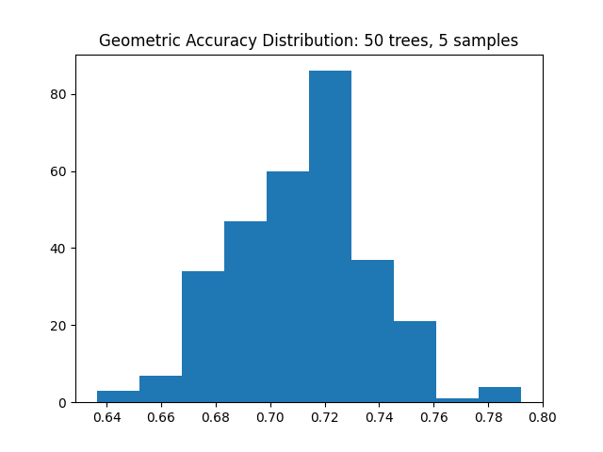
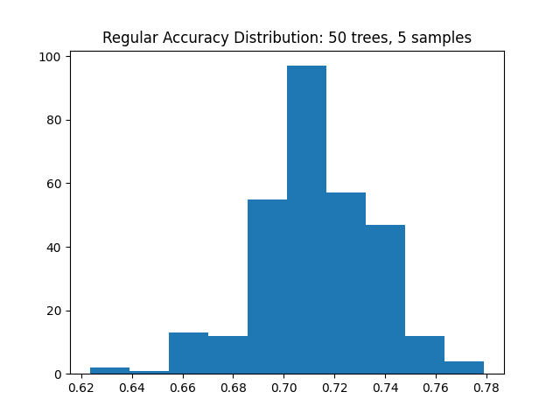
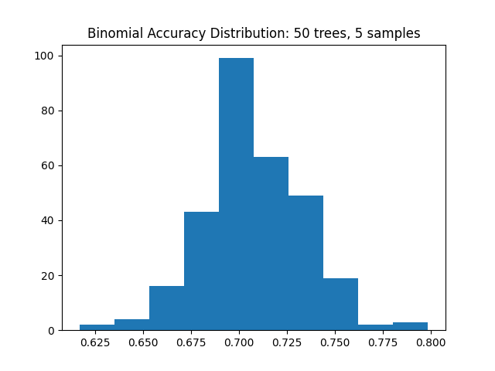
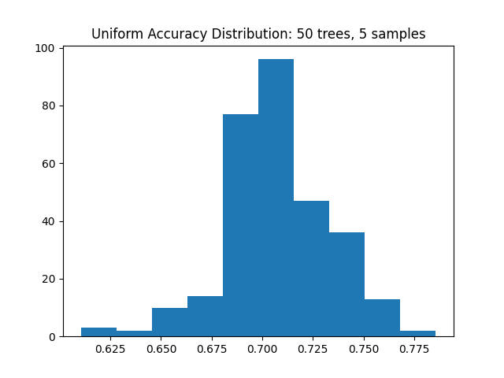
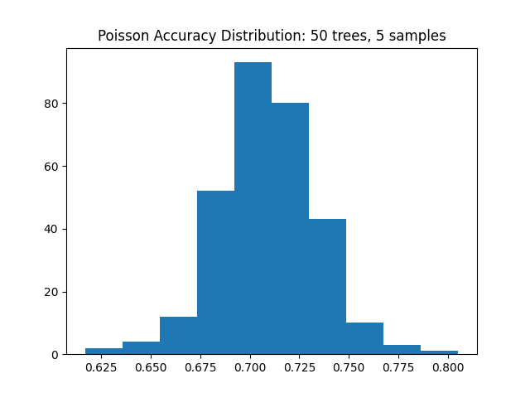
Fig. 3-7. Accuracy distributions for all trials.

In fact, the Poisson trials resulted in a single random forest that performed extraordinarily well. This forest had an accuracy of 80.5% and a sensitivity of 46.8%. In comparison, the most accurate regularly-generated forest had an accuracy of 77.9%. While the sensitivity is much higher at 61.4%, it also predicts false positives at a much higher frequency than the most accurate Poisson forest. This indicates that a forest using a probabilistic distribution has the possibility to better find nuances in data when compared to a regular random forest model.

Conclusion and Future Work

Random forests are machine learning models that rely on adding random elements to decision tree generation and aggregating the results, but adding randomization to the decision of which attributes to “split” on does not greatly impact model performance, nor does it impact it in a positive manner. The regular random forest performed the best, with average accuracy 71.2%, but the other random forests that utilized various probability distributions performed very similarly, each approximately 0.5% or less below the accuracy of the regular random forest. Randomizing which attributes to split on resulted in a few trees that are more useful than the traditionally-created random forest model, though it appeared to make generally similarly-performing trees overall.

If we had more time, more team members, or more computational resources, we would have experimented with different distributions, e.g. a binomial distribution with p = 0.1, different metrics to split based on like Gini impurity, etc. in order to find the best combination of tactics. This would also help us determine if this pattern of more randomness being similar would hold for other metrics besides information gain.

Contributions

We each supervised each other doing the other work and provided input as needed, collaborating on each aspect of the project—we each had a role in each task taken. However, Cameron developed the initial idea, Diana performed the actual Python implementation on her computer and transferred results to the report, and Cameron did the majority of the writing. We each put together the presentation simultaneously.

References

Our dataset, code, and other documents can be found in the following Google Drive folder: https://drive.google.com/drive/folders/1gvtcVlAsFeKIZoUsDJYeC1OXfgYCFyi2?usp=sharing

Our Works Cited can be found on the next page.

Works Cited
Bienemann, André. “Probability Distribution Library for Python.” Python Software Foundation, 2024, https://pypi.org/project/pdlpy/.
Dash, Shailey. “Decision trees explained - entropy, information gain, Gini Index, CCP pruning.” Medium, 2 Nov. 2022, https://towardsdatascience.com/decision-trees-explained-entropy-information-gain-gini-index-ccp-pruning-4d78070db36c.
Harris, C.R., et al. “Array Programming with NumPy.” Nature, 585, 2020, pp. 357–362.
Hunter, J.D. “Matplotlib: A 2D Graphics Environment.” Computing in Science & Engineering, 3 Mar. 2007, pp. 90–95.
Ishwaran, Hemant. “The Effect of Splitting on Random Forests.” Machine Learning, vol. 99, no. 1, Jul. 2014, pp. 75–118. https://doi.org/10.1007/s10994-014-5451-2.
Koehrsen, Will. “Hyperparameter Tuning the Random Forest in Python.” Medium, 9 Jan. 2018, https://towardsdatascience.com/hyperparameter-tuning-the-random-forest-in-python-using-scikit-learn-28d2aa77dd74
McKinney, W., et al. “Data Structures for Statistical Computing in Python.” In Proceedings of the 9th Python in Science Conference. 2010, pp. 51–56.
National Institute of Diabetes and Digestive and Kidney Diseases. "Diabetes Dataset." Edited by Mehmet Akturk. Kaggle, 2021, www.kaggle.com/datasets/mathchi/diabetes-data-set?resource=download.
Nuti, Giuseppe, et al. "An Explainable Bayesian Decision Tree Algorithm." Frontiers in Applied Mathematics and Statistics, vol. 7, 22 Mar. 2021. Frontiers, https://doi.org/10.3389/fams.2021.598833.
Pedregosa, F., et al. “Scikit-Learn: Machine Learning in Python.” Journal of Machine Learning Research, 12 Oct. 2011, pp. 2825–2830.
Rao, Krishna. “Splitting data randomly can ruin your model.” Stanford Data Science, 15 Nov. 2021, https://datascience.stanford.edu/news/splitting-data-randomly-can-ruin-your-model.
Verikas, Antanas, et al. “Mining data with random forests: A survey and results of new tests.” Pattern Recognition, vol. 44, no. 2, 2011, pp. 330-349. https://doi.org/10.1016/j.patcog.2010.08.011.
Wang, Quinn. “Beware of the Very Random Forest.” Medium, 29 Feb. 2020, https://towardsdatascience.com/beware-of-the-very-random-forest-680a0c1132de.
Zaim, Samir Rachid, et al. “binomialRF: Interpretable Combinatoric Efficiency of Random Forests to Identify Biomarker Interactions.” BMC Bioinformatics, vol. 21, no. 1, Aug. 2020, https://doi.org/10.1186/s12859-020-03718-9.

